Course Title | Human Computer Interaction | Code | CSSE 4153
Credit Hours | 3.0 | Level | Undergraduate
Class | BSCS | Total Enrollment | 46
Course Instructor | Prof. Sabah Arif | CLO | 3

HCI-FIGMA PROJECT

FIGMA LINK:
DESIGN LINK
PROTOTYPE LINK

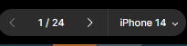

First move to the display number 10 to start from the main page IF ITS NOT 10 BY DEFAULT

DISPLAY 1:
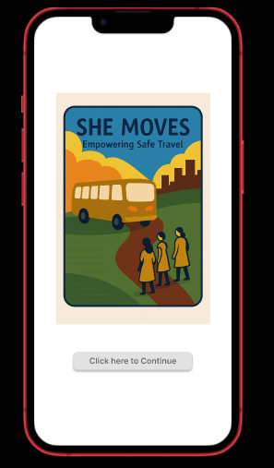

- This is the first display (shown as display number 10).As shown in the screenshot Click on the pointed area to continue.
DISPLAY 2:
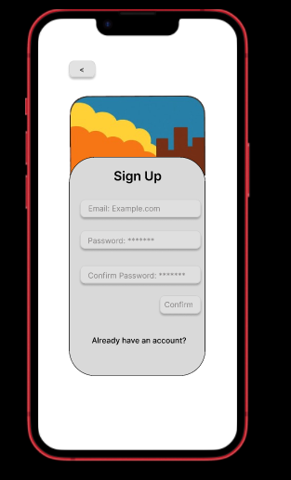
- After clicking that this SigN up display will pop up. Click “already have an account” if you got one else click confirm. If you click back button in the top left corner it will go back to the previous logo page.

DISPLAY 3:
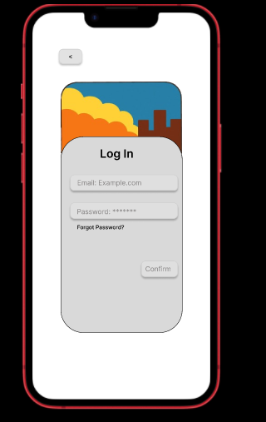
- By clicking the “already have an account”, this login display will pop up.By clicking the back button her on the top left corner will take you to the lsame starting logo page of the app.
DISPLAY 4:
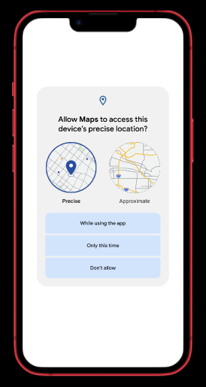
- This is what appears as soon as you click CONFIRM either on sign up display or on login display.Now by clicking on any of the given options it will take you to the next display.
DISPLAY 5:
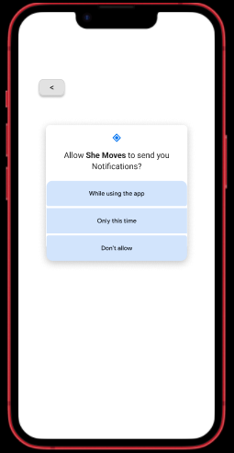
- The back button will take you to the prev display and by clicking any of the given options it will take you to the next display.

DISPLAY 6:
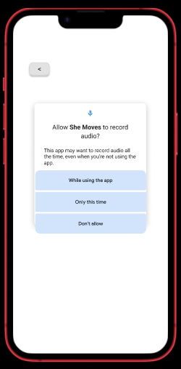
- The back button will take you to the prev display and by clicking any of the given options it will take you to the next display.

DISPLAY 7:
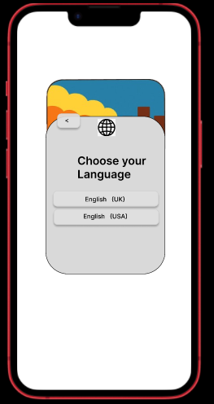
- Clicking the back button will take you to the prev display and by clicking any of the given options it will take you to the next display.

DISPLAY 8:
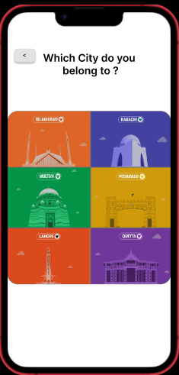
- Clicking the back button will take you to the prev display and by clicking any of the given options it will take you to the next display.
DISPLAY 9:

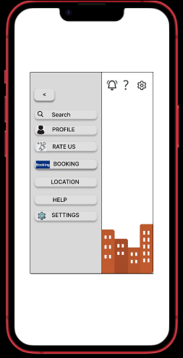
- Clicking the back button will take you to the prev display and by clicking any of the given options it will take you to the next respective display you’ve chosen.
DISPLAY 10:
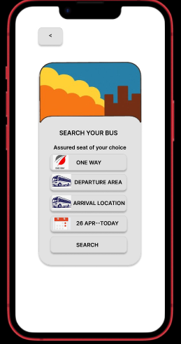

- By clicking search in the prev display well get this display now by clicking back button on this display well go back to prev display n by clicking the given “one way” option well go to next display.
DISPLAY 11:
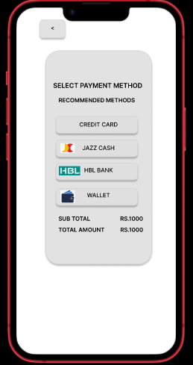
- By clicking “one way” in the prev display well get this display now by clicking back button on this display well go back to prev display n by clicking the given options well go to next display.
DISPLAY 12:

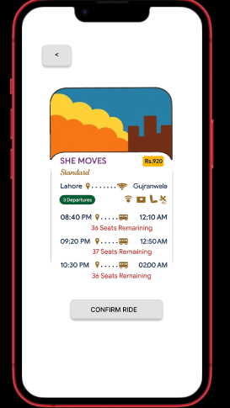

- By selecting the payment method from the prev display well get this display now by clicking “confirm ride”, our ride will be confirmed and a confirmed display will pop up.
DISPLAY 13:

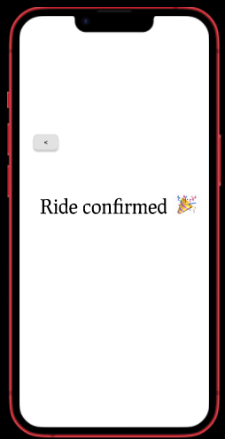
- This display will pop up when we confirm our ride and by clicking the “BACK BUTTON” given here well go back to the option from where we had selected search.
DISPLAY 14:

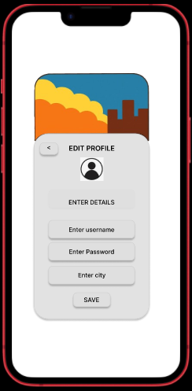
- By selecting the “profile” on that display we woill get this display and by clicking back button well go back to that prev display from where we had selected “profile” and by clicking the “save” button here our details will be saved and a “saved” display will pop up.
DISPLAY 15:

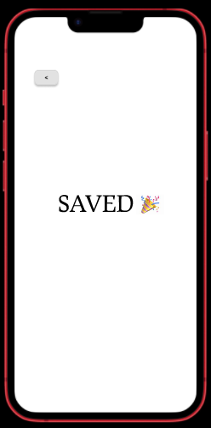
- This display will pop up once we save our details and by clicking the back button here we will go back to the display from where we had selected “profile”.
DISPLAY 16:

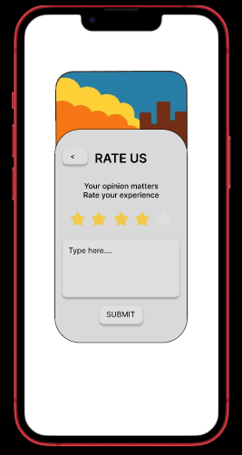
- Now by clicking the “rate us” from that display we will get this display where stars are responsive and by clicking submit our feedback will be submit and a display saying “submited” will pop up and by clicking the back button here we will go back to the display from where we had selected “rate us”.
DISPLAY 17:

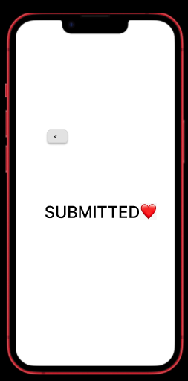
- This display will pop up when we submit it and by clicking the back button here we will go back to the display from where we had selected “rate us”.
DISPLAY 18:

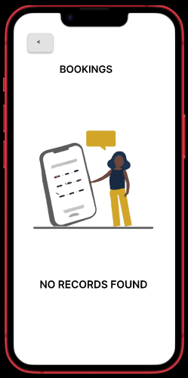
- Then by clicking the bookings we will get this display and by clicking the back button here we will go back to the display from where we had selected “booking”.
DISPLAY 19:

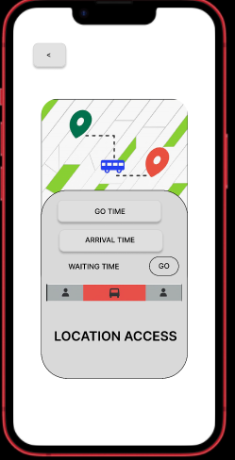
- Then by clicking the location we will get this display and by clicking the back button here we will go back to the display from where we had selected “location”.
DISPLAY 20:

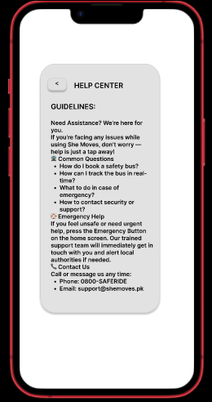
- Then by clicking the help we will get this display and by clicking the back button here we will go back to the display from where we had selected “help”.
DISPLAY 21:

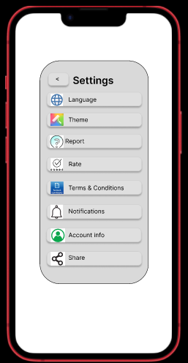
- Then by clicking the settings we will get this display and by clicking the back button here we will go back to the display from where we had selected “settings”.Now well select further options from here where valid ones are language,report rate,notification,account info.
DISPLAY 22:

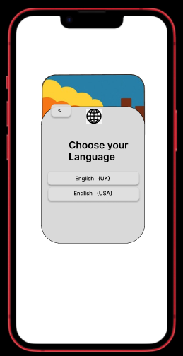
- By clicking “language ” from settings we will get this again now to get back to the prev page of setting just move your mouse to back button and then move your mouse back from back button without clicking it and as a result well go back to the prev setting page as it has been set to go back their on “mouse leave” mode.And to choose the language don’t click the language this time else click and drag the option and it will take you the next display saying “Choosed”.
DISPLAY 23:

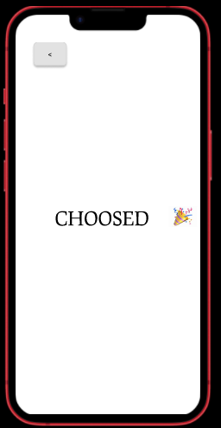
- By clicking the back button here we will go back to the setting page from where we had selected language.
DISPLAY 24:

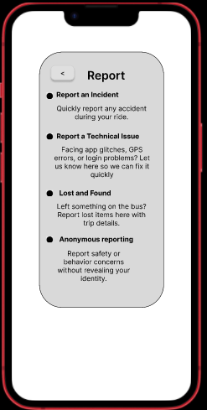
- By clicking the “report” ffrom the setting page we will get this display and by clicking the back button here we will go back to the setting display.
DISPLAY 25:

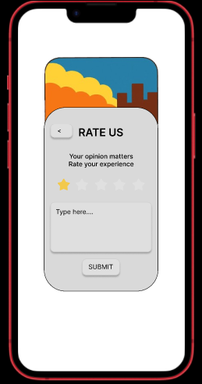
- Then by clicking “rate us ” from setting display this will pop up again as we did before rate the app by clicking on the responsive stars and submit it and again submit display will pop up.but if we decide to go back from here without submitting we just move our mouse to back button and leave from there without clicking it to access the setting display back.
DISPLAY 26:

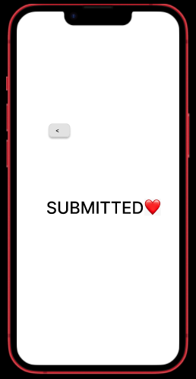
- After clicking submit from prev display we will get this display ang to get back to the setting display we just move our mouse to back button and leave from there without clicking it to access the setting display back.

DISPLAY 27:

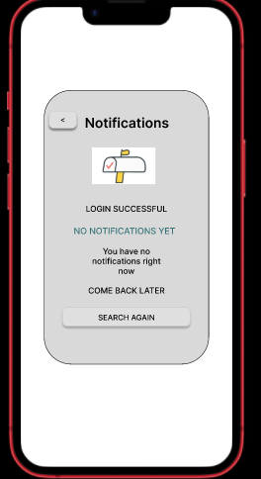
- By clicking the “notification” option on the setting display we will get this display and by clicking the back button we will get back to the setting display.
DISPLAY 28:

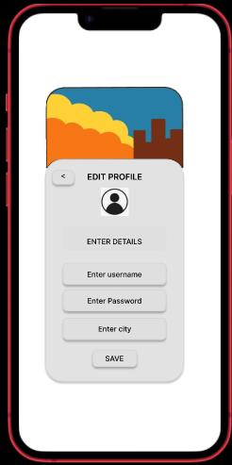
- By clicking the “profile” option on the setting display we will get this display and by just moving the mouse to back button and then drag the cursor back without clicking we will go back to setting display and by clicking save here as before we will get a display saying “saved”.
DISPLAY 29:

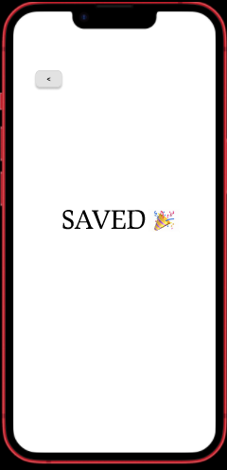
- By clicking the “save” we will get this display and by just moving the mouse to back button and then drag the cursor back without clicking we will go back to setting display.

THE END

